Project Report

This project’s goal was to forecast the tourist number coming in to Turkey, considering various exchange rates and countries. We found past data on Russian Ruble, Sterlin and Euro and numbers of coming in Russian/English/German tourist numbers from various sources. Since TRY is losing value these days, we realised that the tourism sector can experience a boost and old forecasts might be unvalueable.

Our main aim was to examine the effects of exchange rates on the tourism sector and tourist numbers. We used correlation, covariance and linear regression to examine this relationship. To conduct linear regression analysis we used Sci-Kit. We also used matplotlib library to sketch graphs for our linear regression analysis.

Prediction for German tourist for todays exchange rate is:

[[334942.30379994]]

Correlation between exchange rate and number of tourist of Germany is :

Euro ALMANYA

Euro 1.000000 -0.084866

ALMANYA -0.084866 1.000000

Covariance between exchange rate and number of tourist of Germany is :

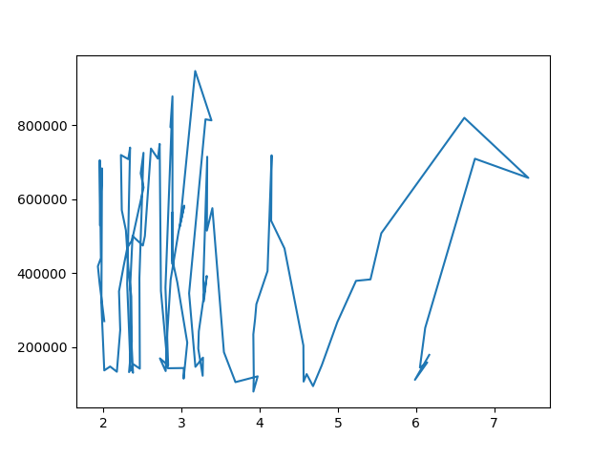 Euro ALMANYA

Euro 1.491129 -2.363948e+04

ALMANYA -23639.476808 5.203464e+10

Figure 1. Plot on Euro-German Tourists

Prediction for British tourist for todays exchange rate is:

[[141919.53223525]]

Correlation between exchange rate and number of tourist of England is :

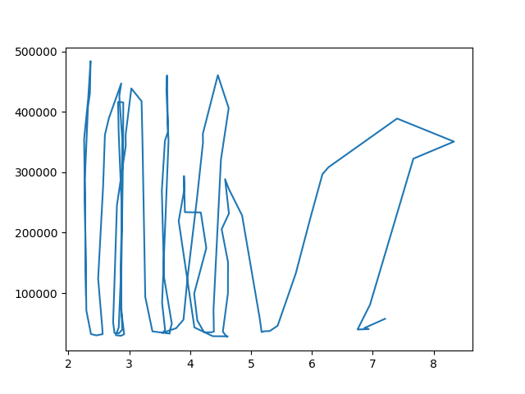 Sterlin INGILTERE

Sterlin 1.000000 -0.127463

INGILTERE -0.127463 1.000000

Figure 2. Plot on Sterlin-English Tourists

Covariance between exchange rate and number of tourist of England is :

Euro ALMANYA

Euro 1.491129 -2.363948e+04

ALMANYA -23639.476808 5.203464e+10

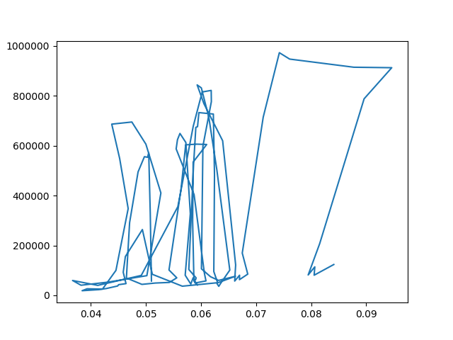

Figure 3. Plot for Ruble- Russian Tourists

Prediction for Russian tourist for todays exchange rate is:

[[594167.09342183]]

Correlation between exchange rate and number of tourist of Russia is :

Ruble RUSYA

Ruble 1.000000 0.295425

RUSYA 0.295425 1.000000

Covariance between exchange rate and number of tourist of Russia is :

Euro ALMANYA

Euro 1.491129 -2.363948e+04

ALMANYA -23639.476808 5.203464e+10